Models

Change env: ***conda activate tf_m1***

# Input

* 70% training data, 20% validation, 10% test
* For Keras training, you need the shape like:

(NumberOfExamples, TimeSteps, FeaturesPerStep)

* + **(numberOfEarthquakes, 61, 58) - 2 Hz**
  + **(numberOfEarthquakes, 151, 58) - 5 Hz**
  + **(numberOfEarthquakes, 301, 58) - 10 Hz**
  + **(numberOfEarthquakes, 15001, 58) - 50 Hz**

series 1: 0.1, 0.2, 0.3, 0.4, 0.5, 0.6, 0.7, 0.8, 0.9, 1.0

series 2: 1.0, 0.9, 0.8, 0.7, 0.6, 0.5, 0.4, 0.3, 0.2, 0.1

data = array([

[0.1, 1.0],

[0.2, 0.9],

[0.3, 0.8],

[0.4, 0.7],

[0.5, 0.6],

[0.6, 0.5],

[0.7, 0.4],

[0.8, 0.3],

[0.9, 0.2],

[1.0, 0.1]])

data = data.reshape(1, 10, 2)

* 50% earrthquake, 50% normal
* Randomly shuffled
* Split data multiple times for better results
* Consistent 0,1s in train, validation, test
* Avoid downsampling (Try 5, 10, 50 HZ)

**To avoid overfitting (Report results)**

* Add regularizer to loss function (loss funct + small scaler * regularizer) - l1 vs l2
  + LSTM:
    - L1: Val loss keeps increasing
    - L2: Val loss keeps increasing
  + CNN:
    - L1: Val loss keeps increasing
    - L2: Val loss keeps increasing
  + CNN-LSTM:
    - L1: Val loss keeps increasing
    - L2: Val loss keeps increasing
* Dropout Rate
  + LSTM: 0.4 - decreases val loss and increases val acc
  + CNN: 0.5 - decreases val loss and increases val acc
  + CNN+LSTM: 0.6 - decreases val loss and increases val acc
* Batch Normalization
  + CNN: decreases TP drastically which is not desired with no change in validation accuracy
  + LSTM: Model doesn’t learn
  + CNN+LSTM: Val loss increases drastically with no change in val acc

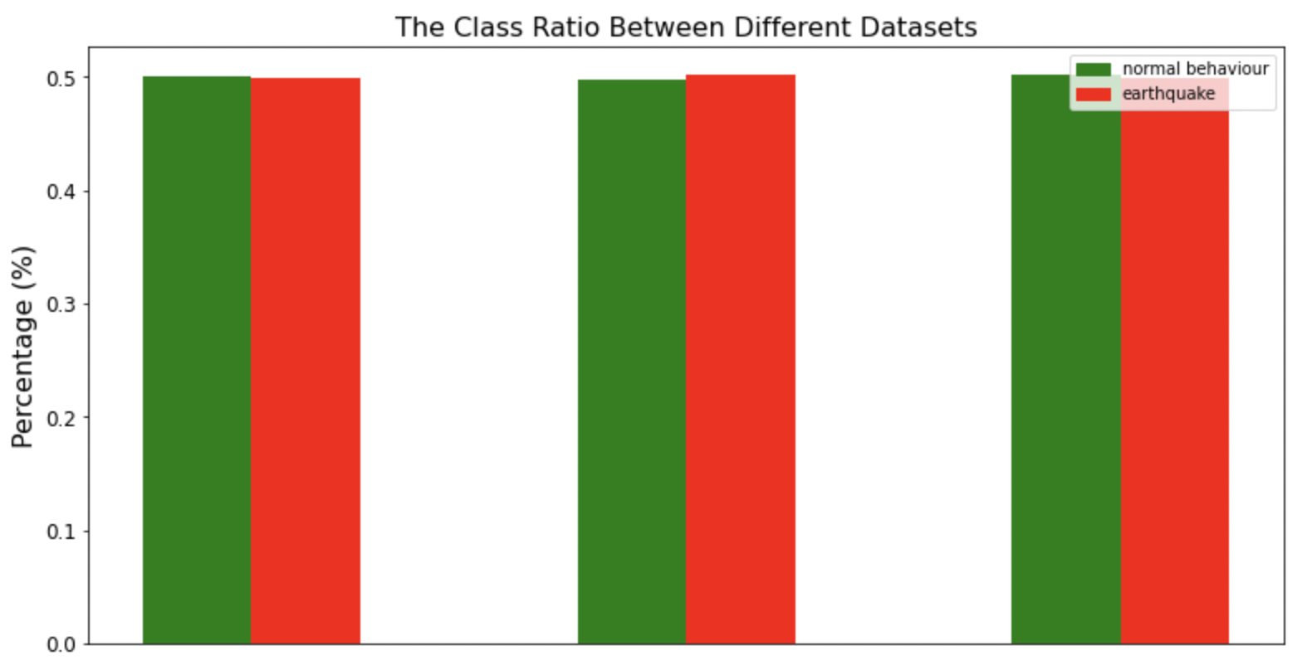

Training Data Validation Data Test Data

## Hyperparameter tuning

* Grid search used

## Results

### 2HZ

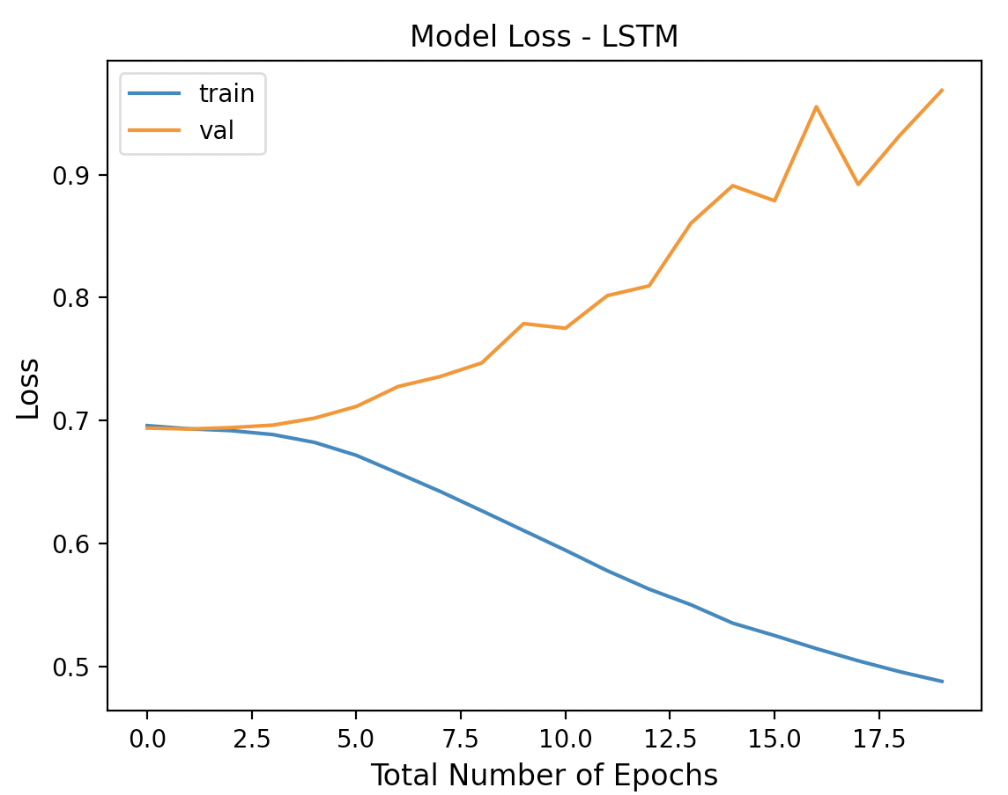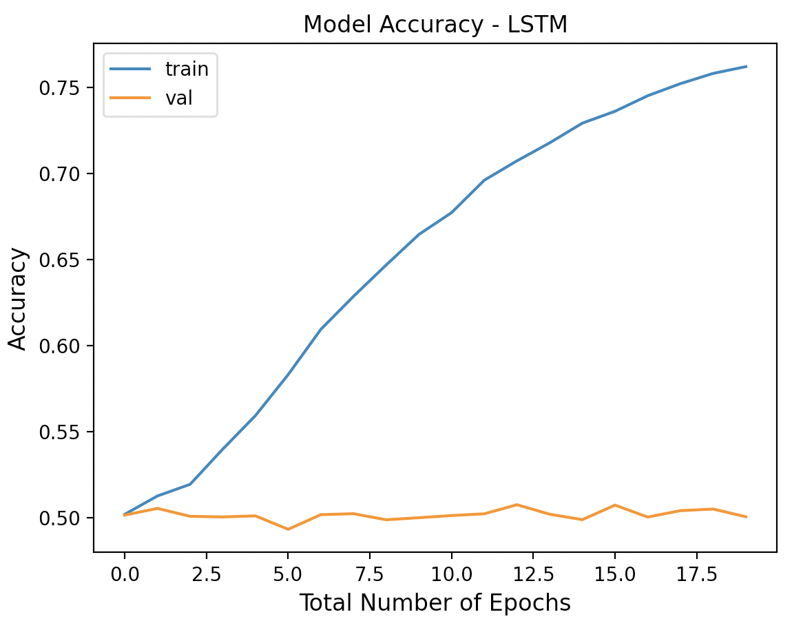

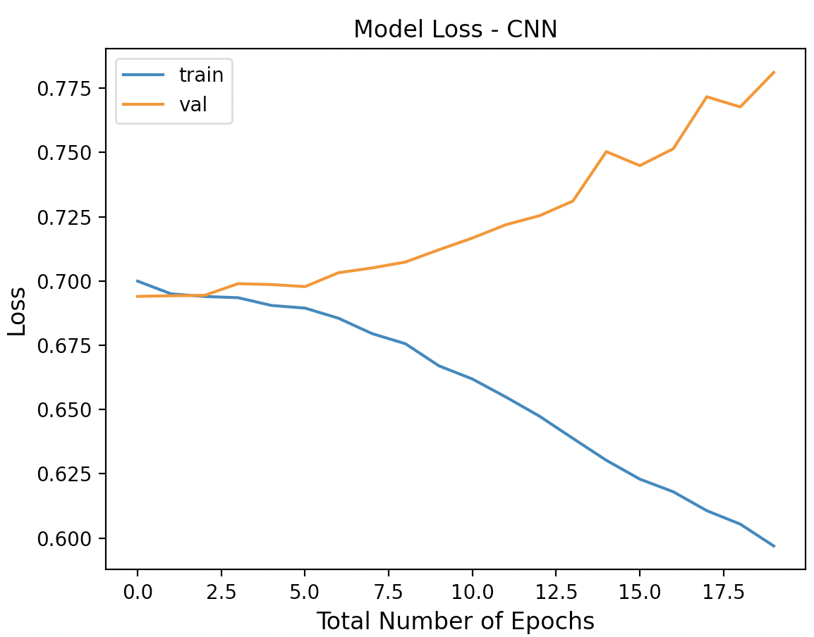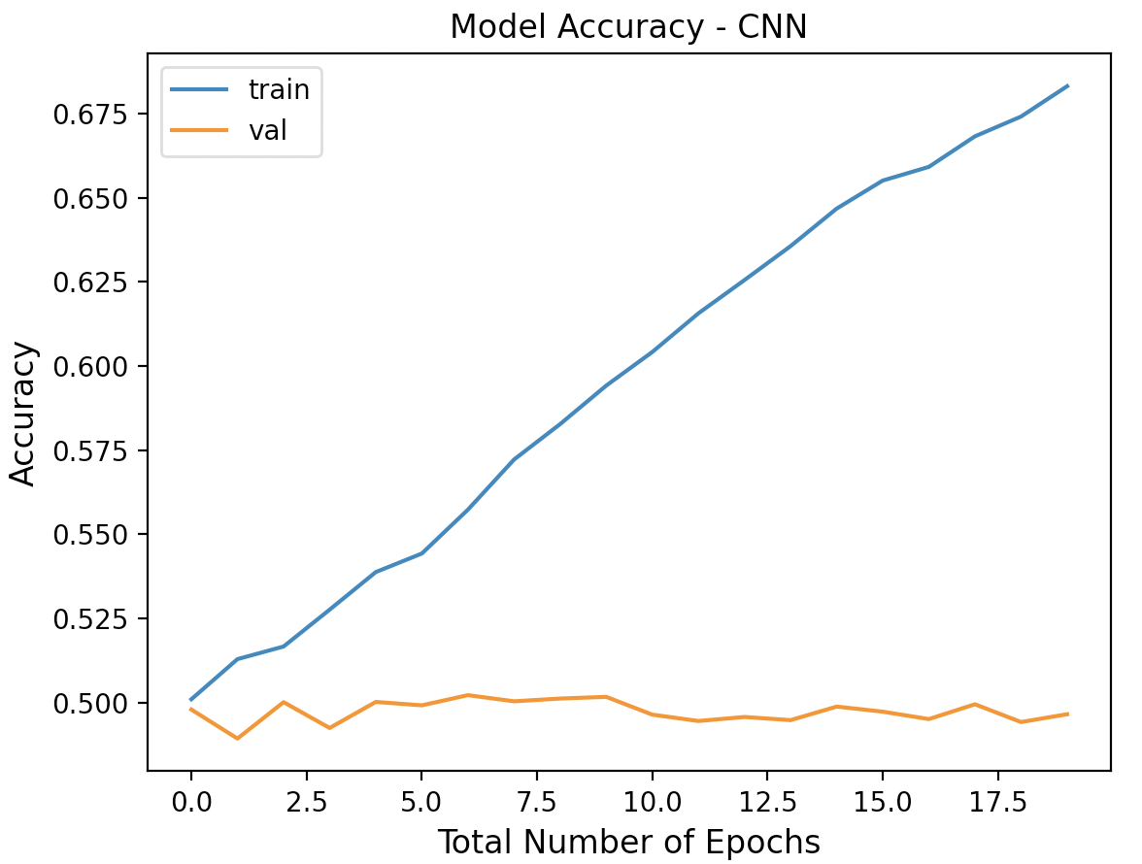

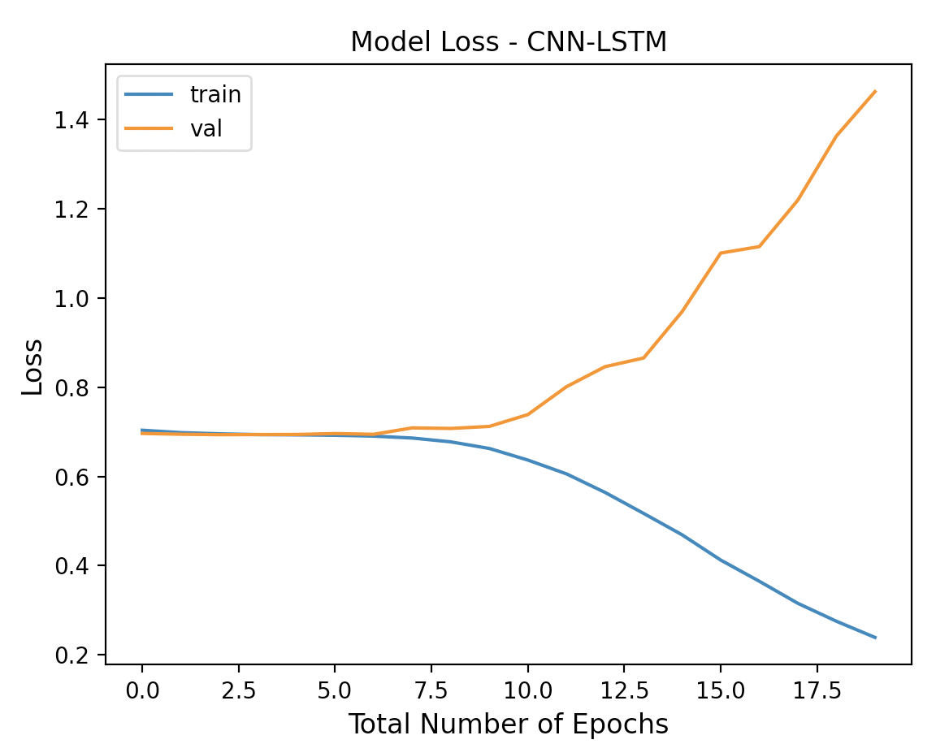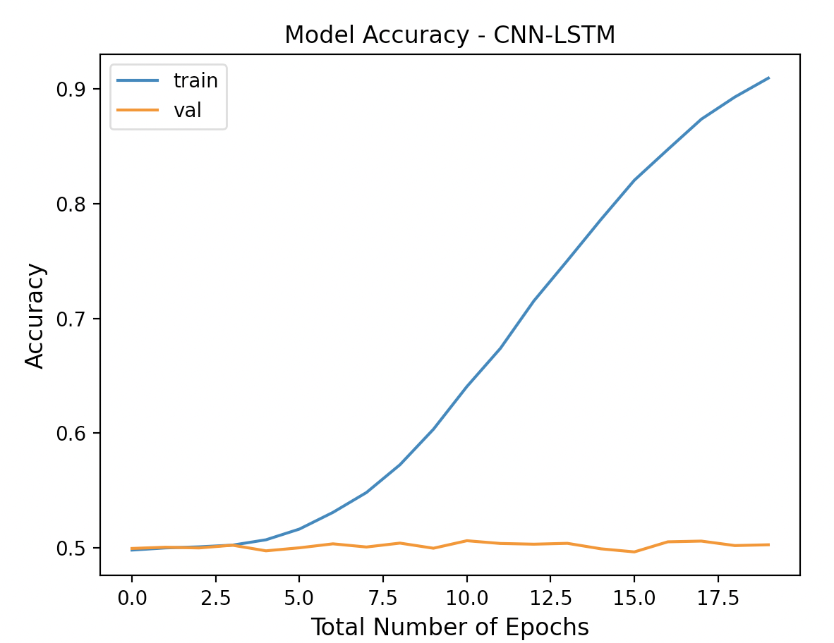

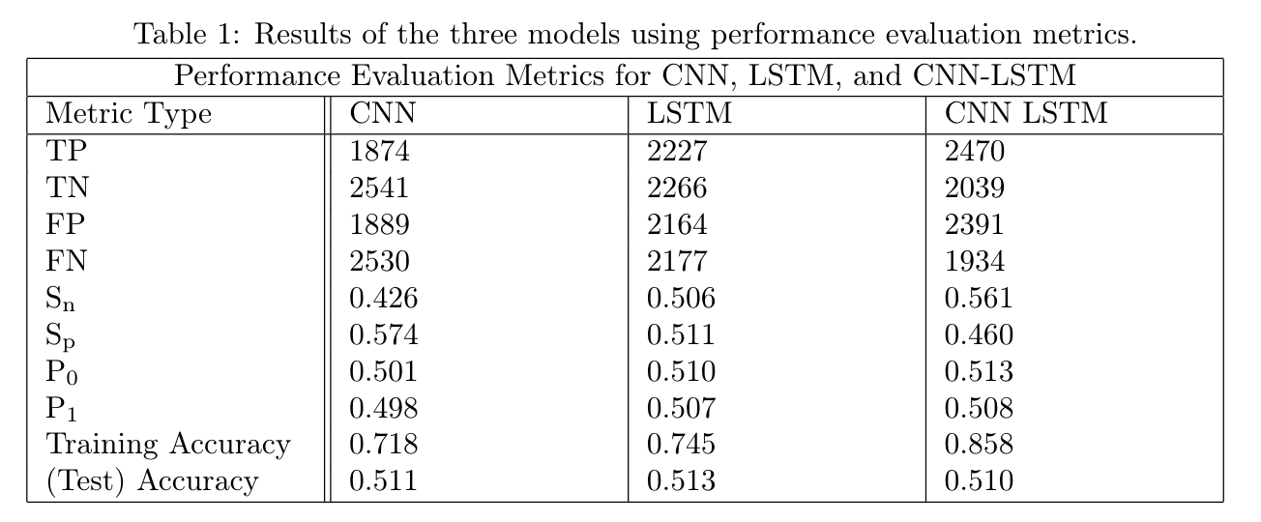

### 5HZ

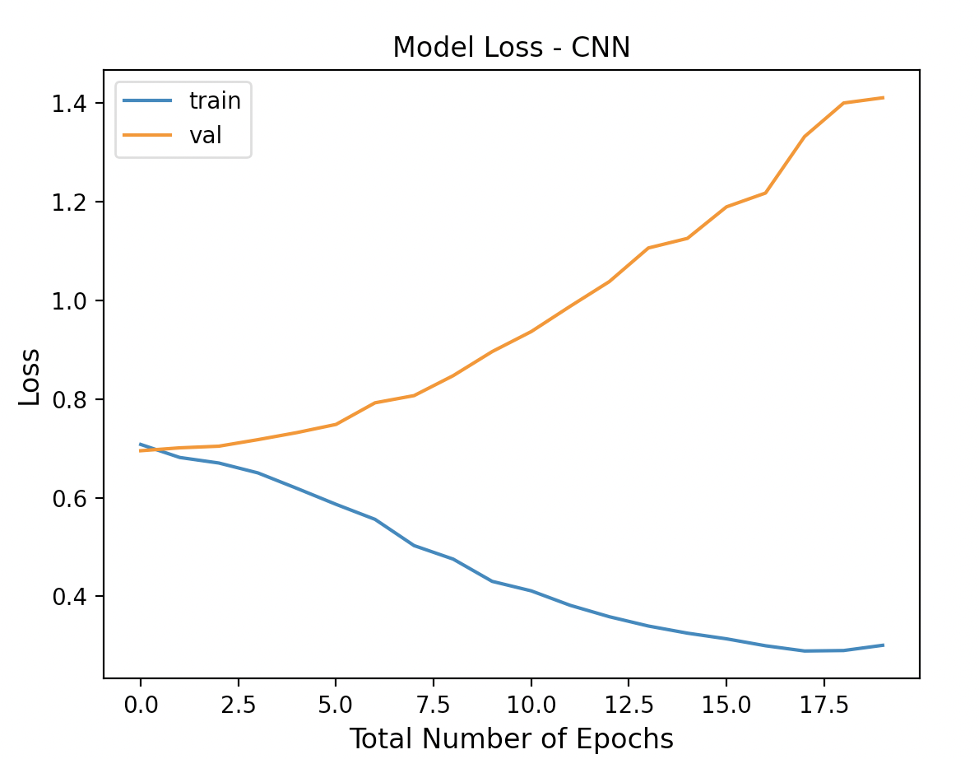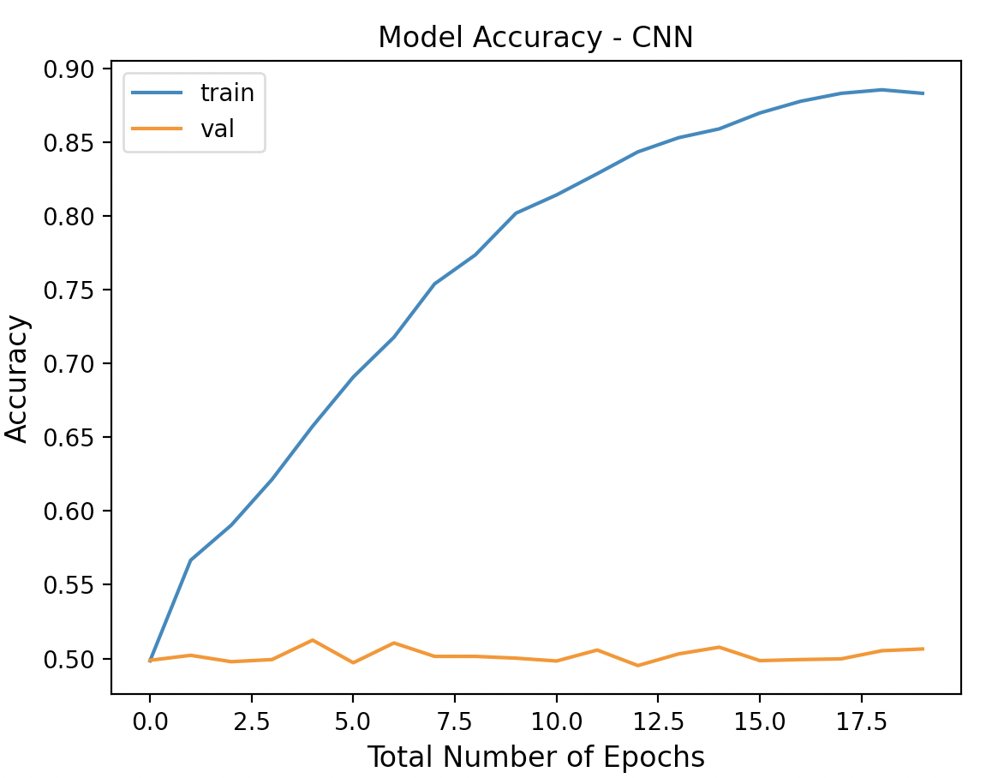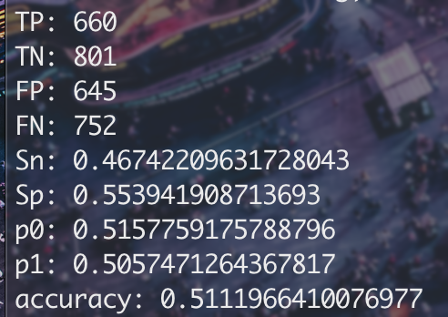

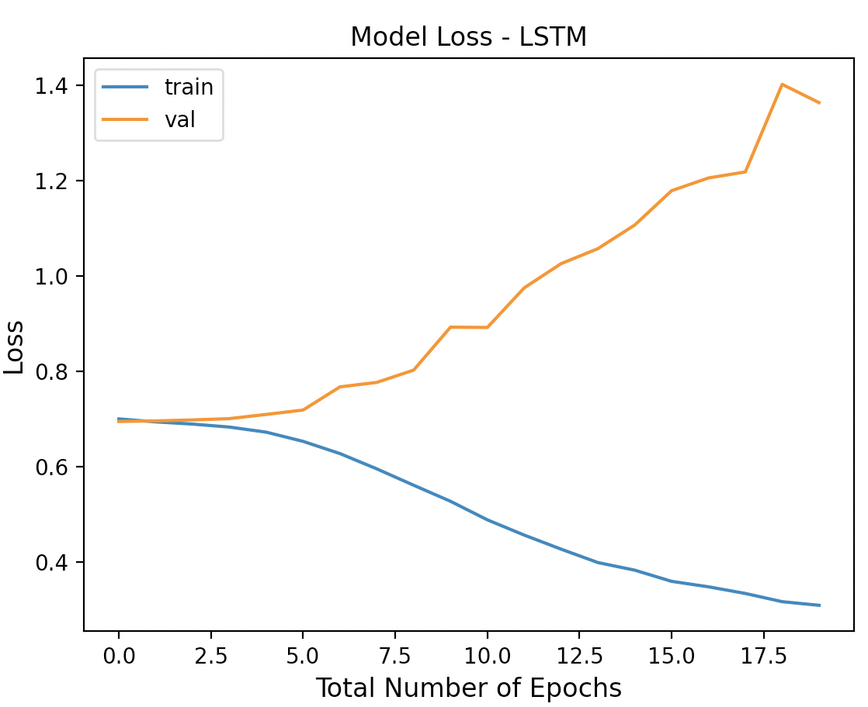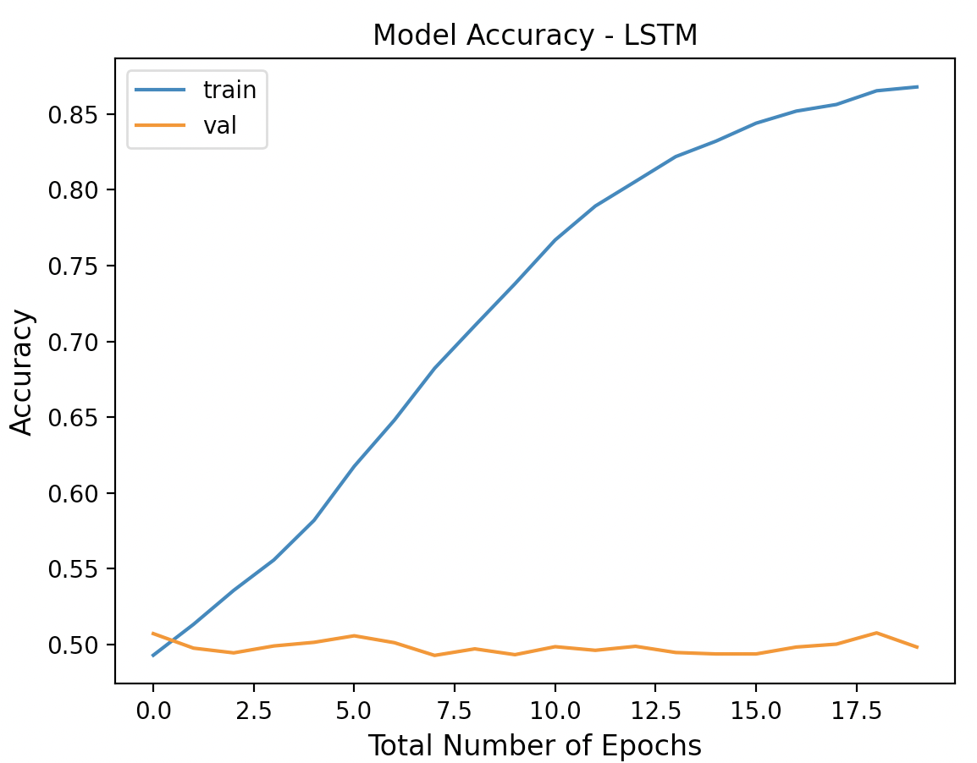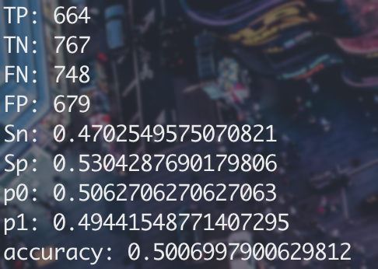

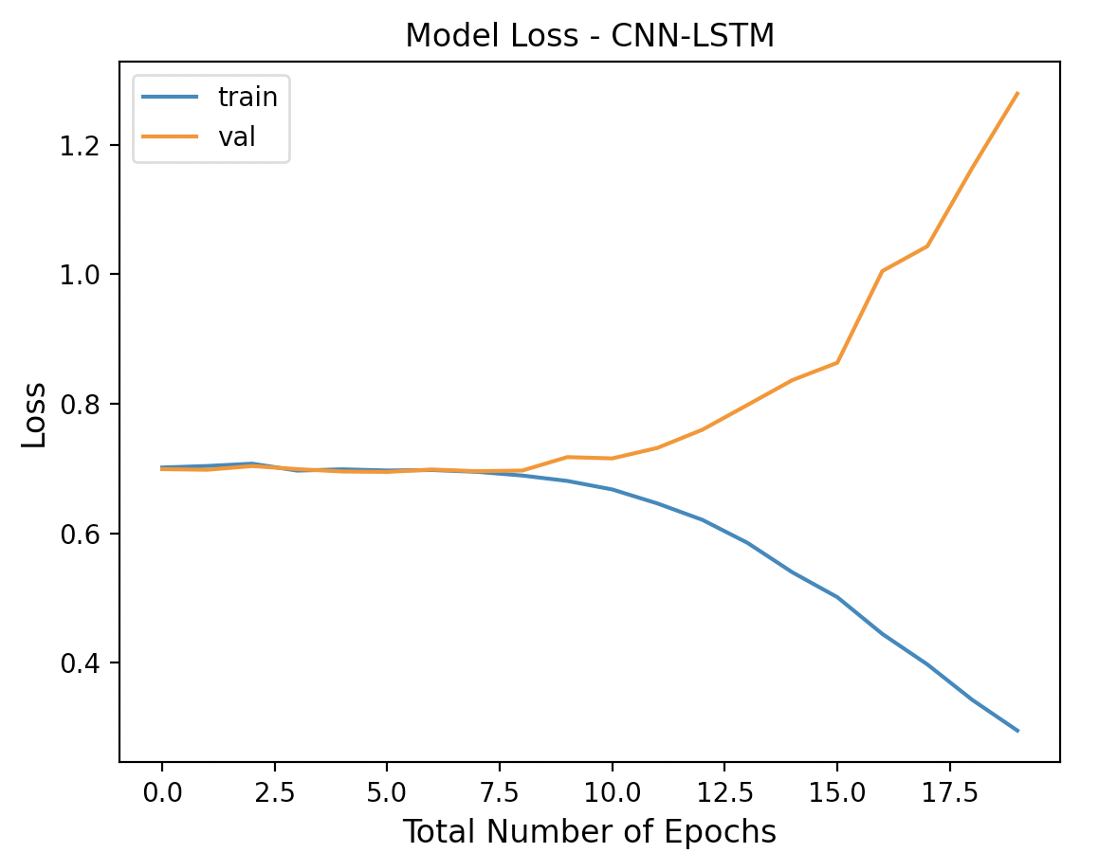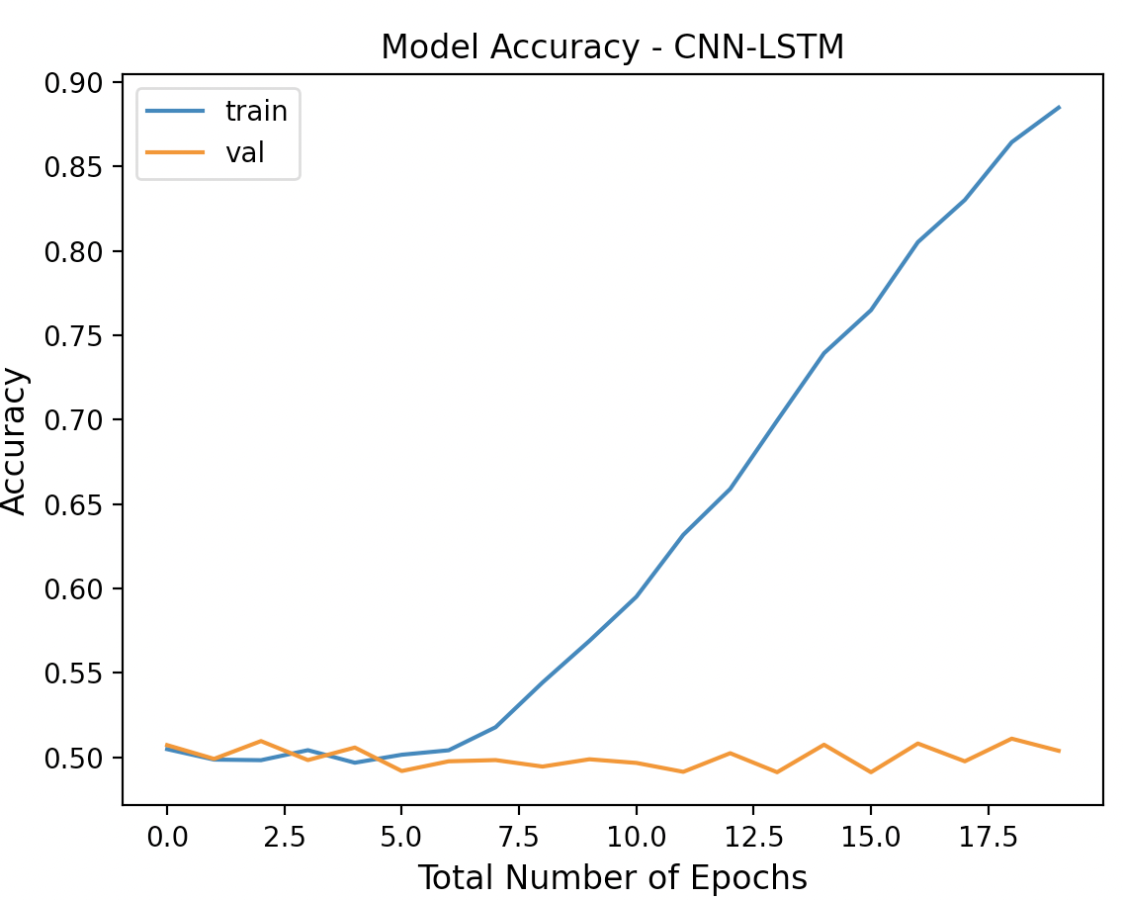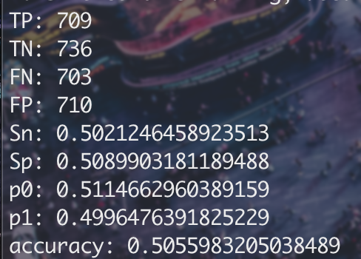

### 10HZ

# 

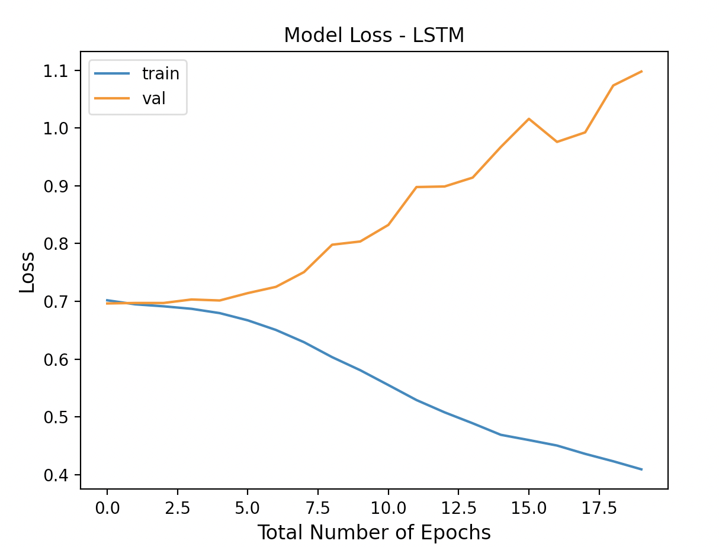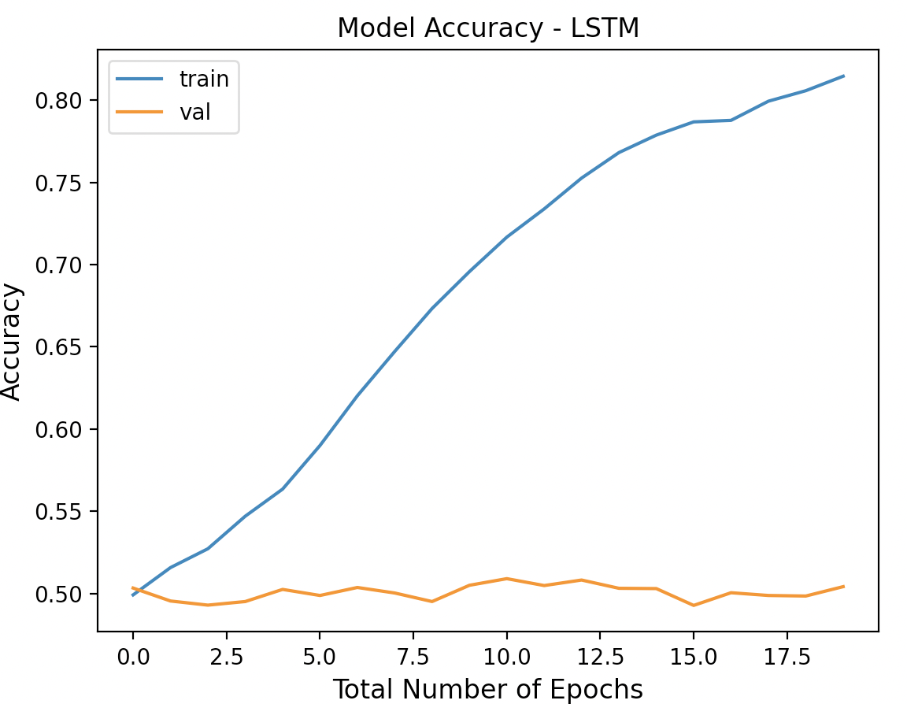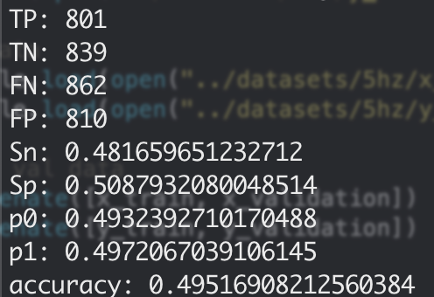

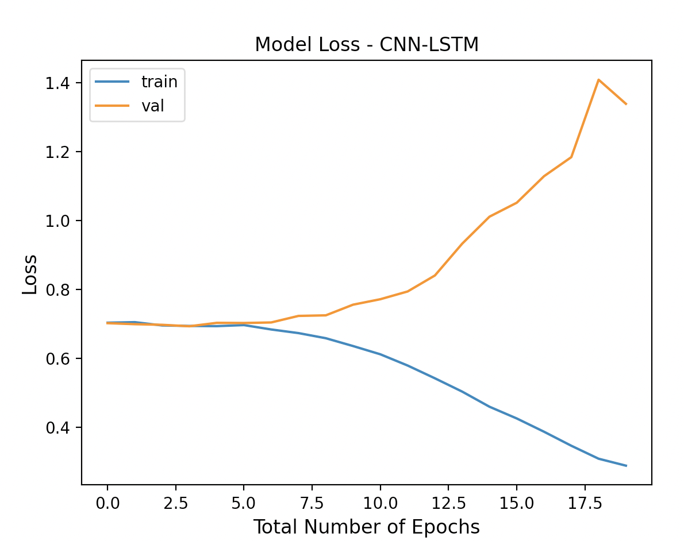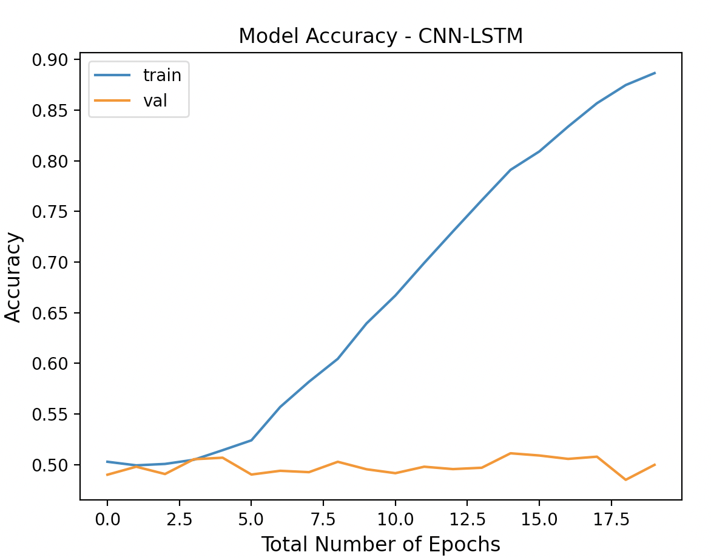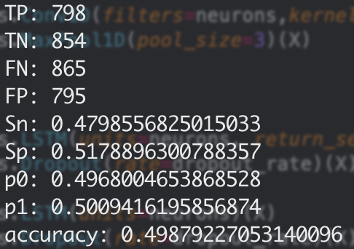

### 25HZ

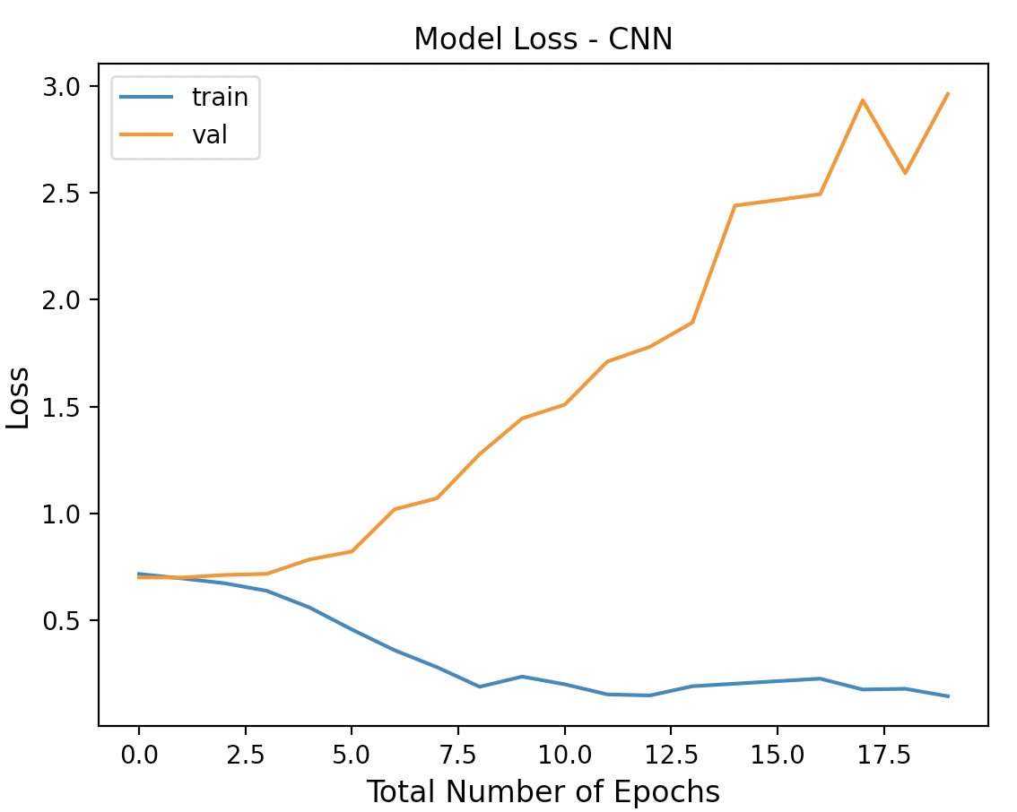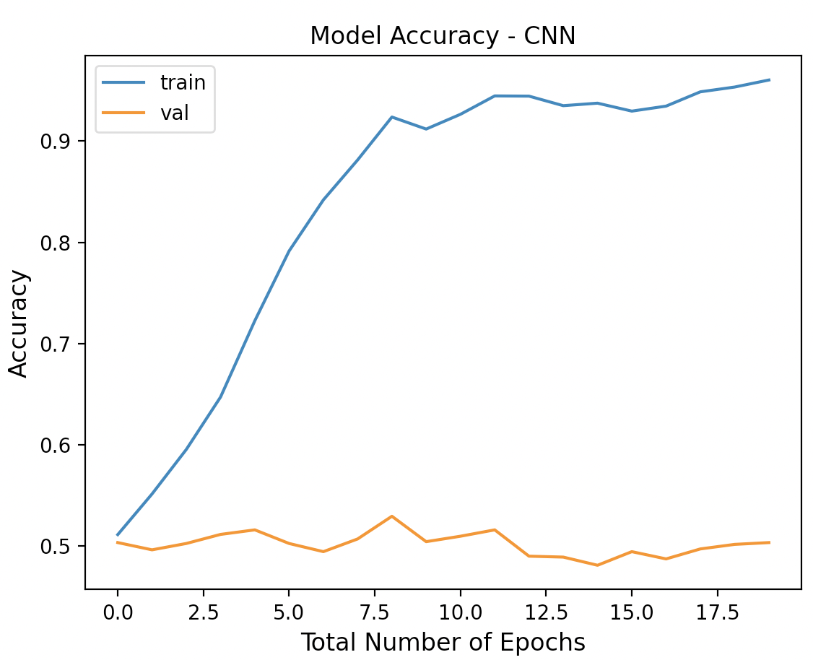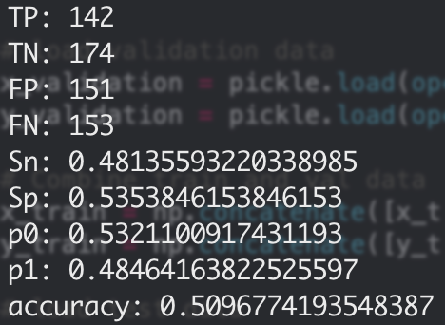

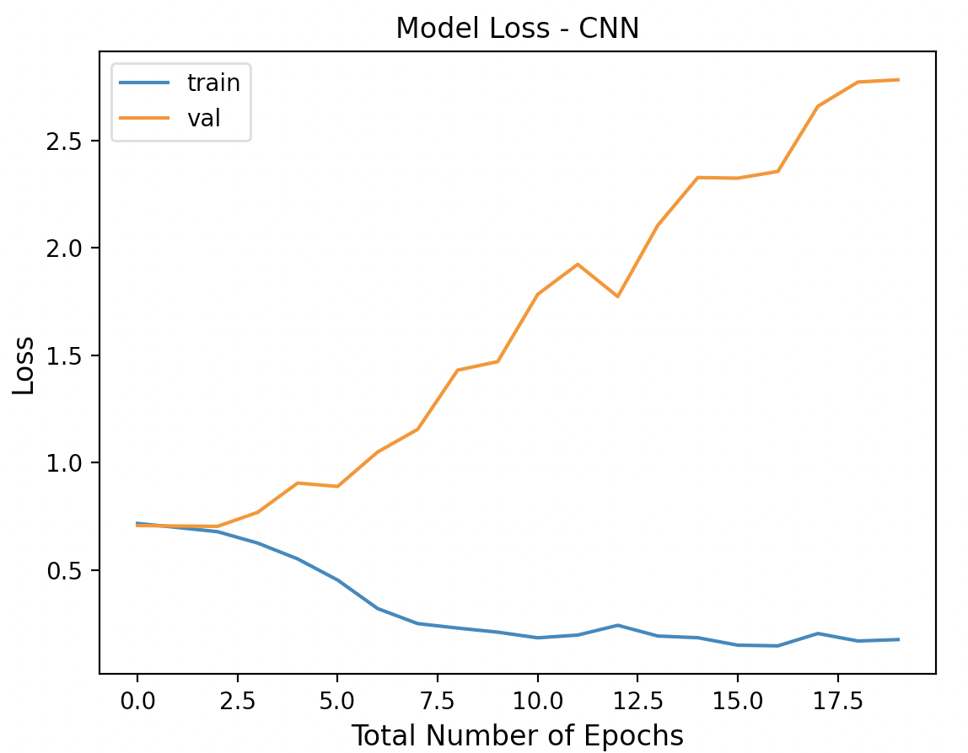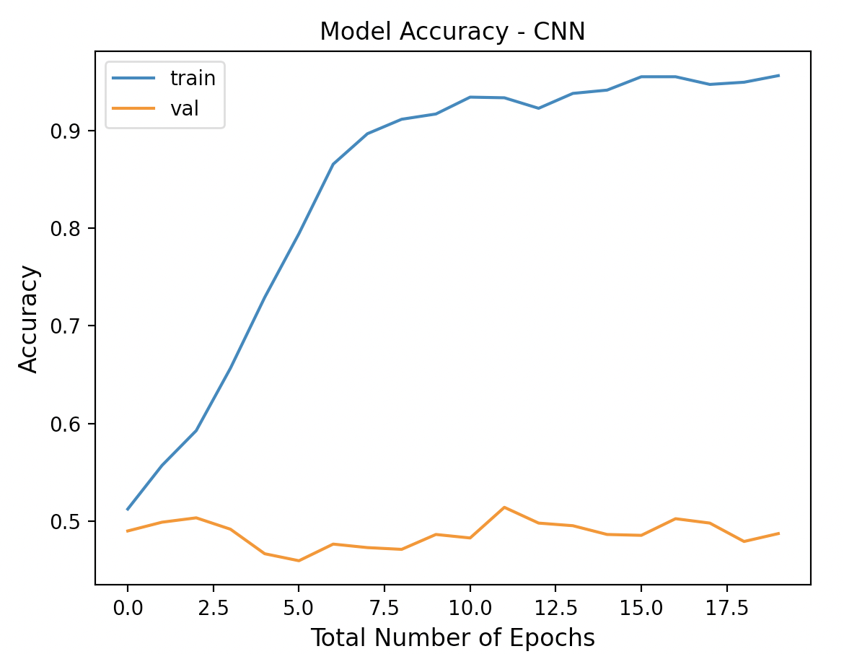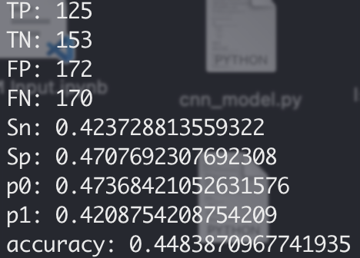

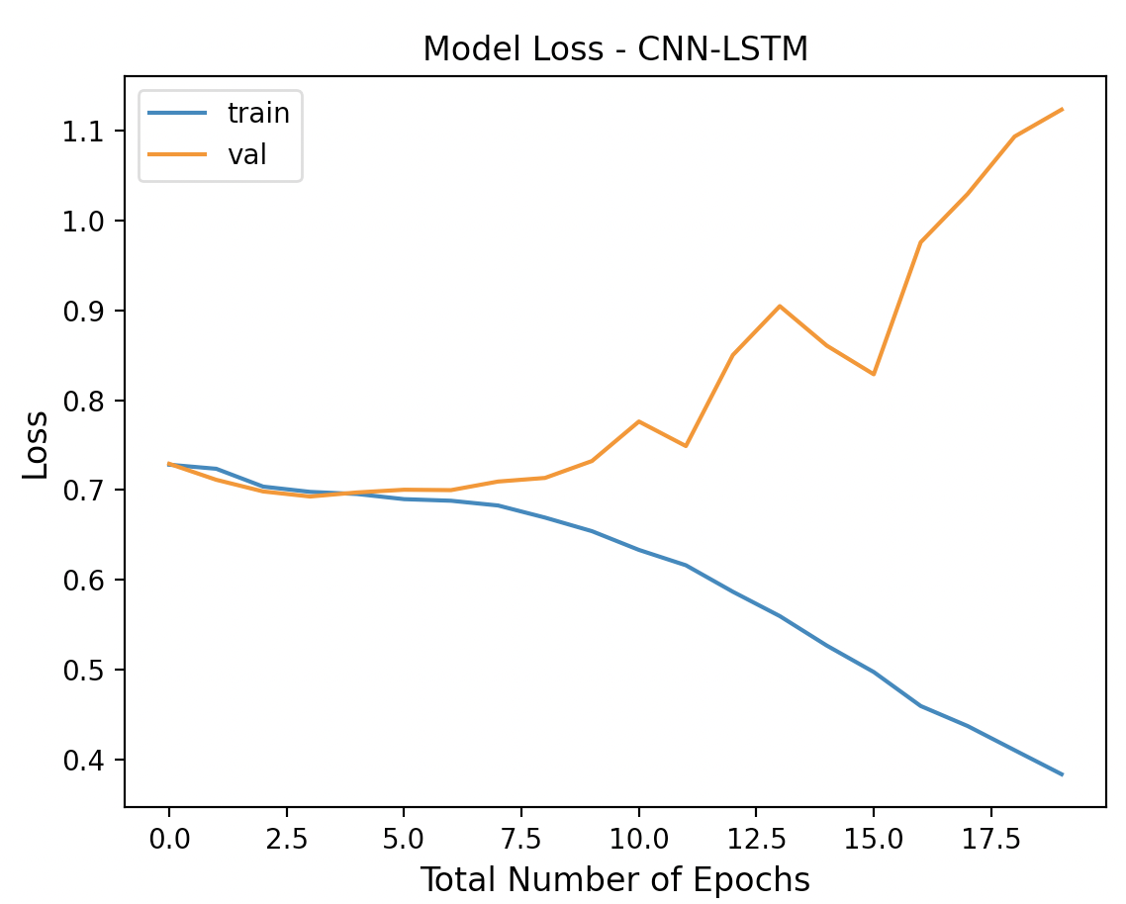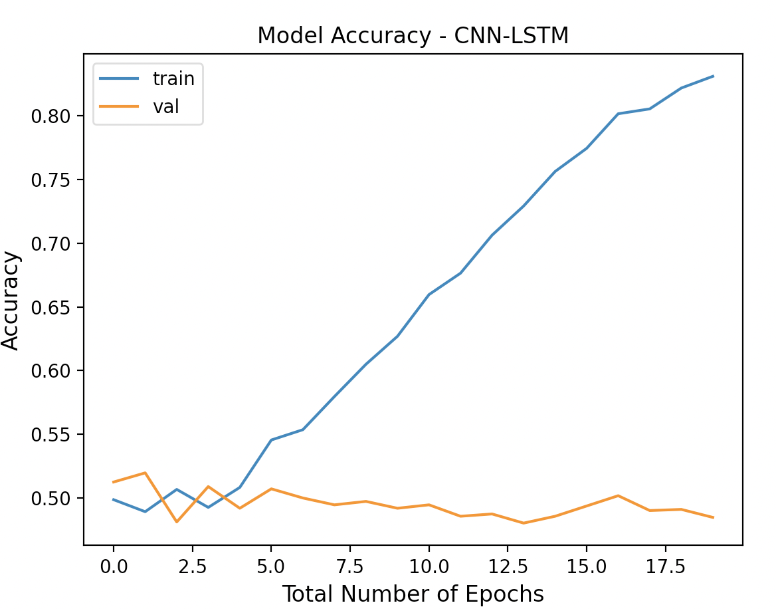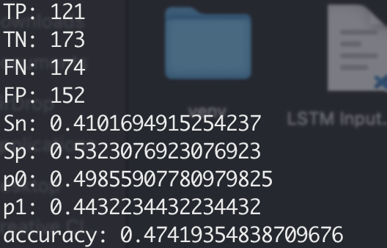

### 

### 50HZ

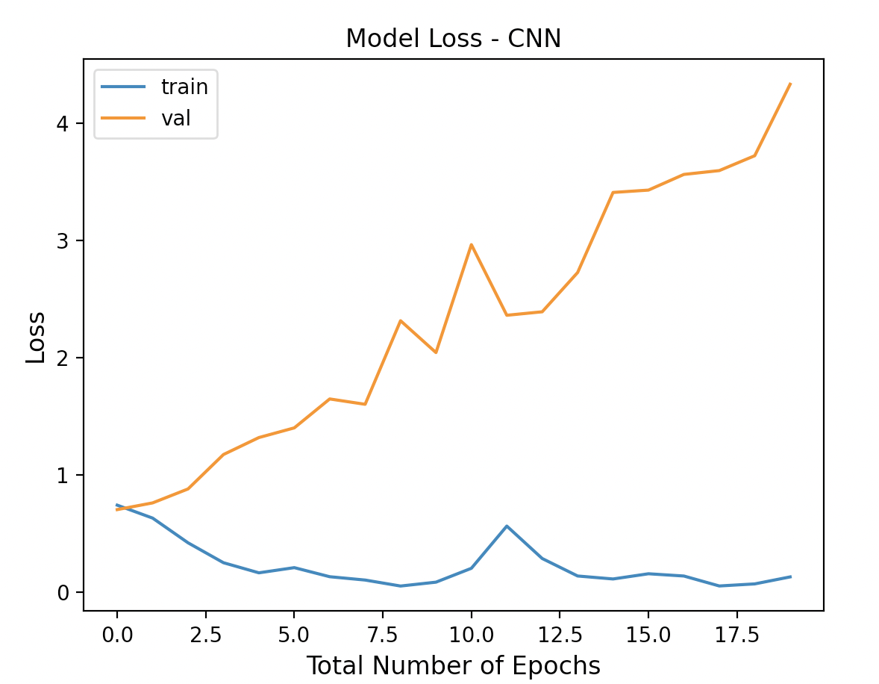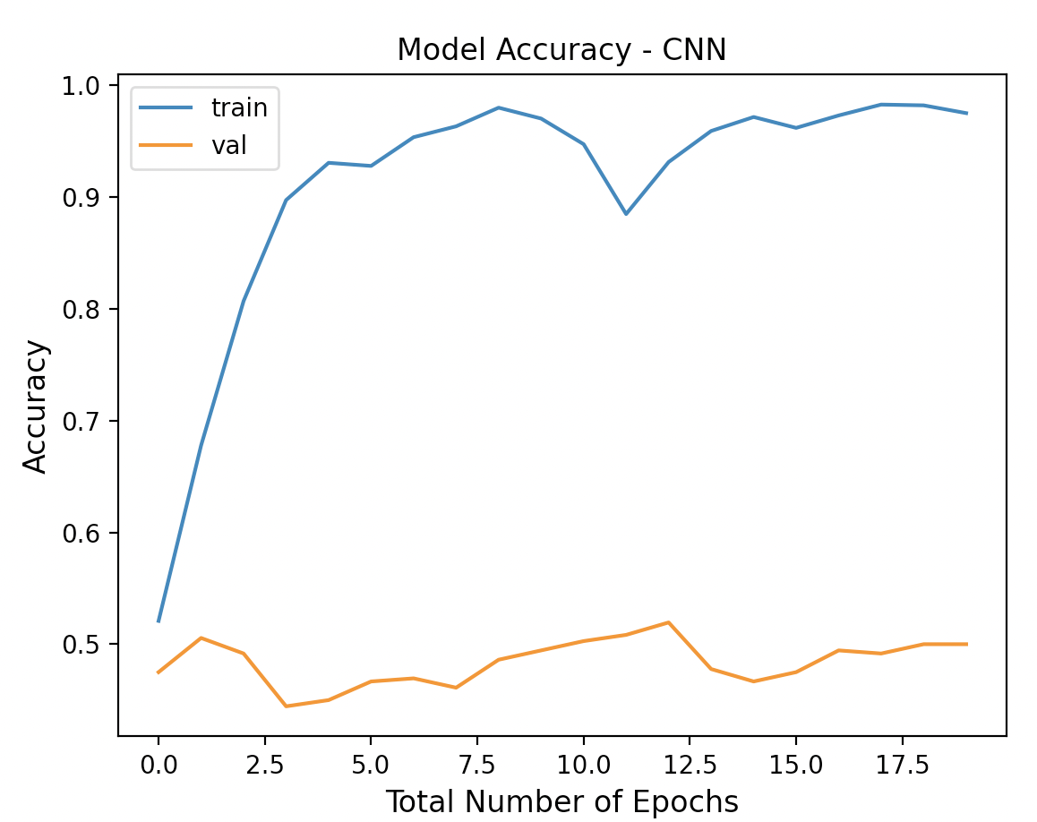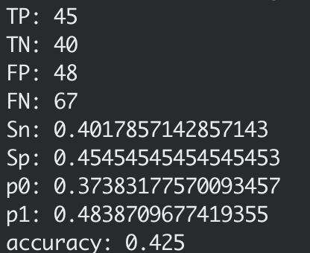

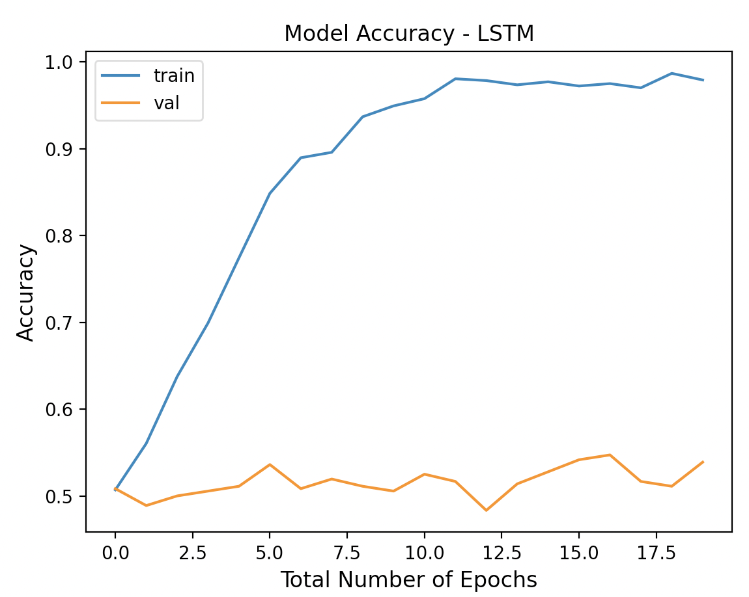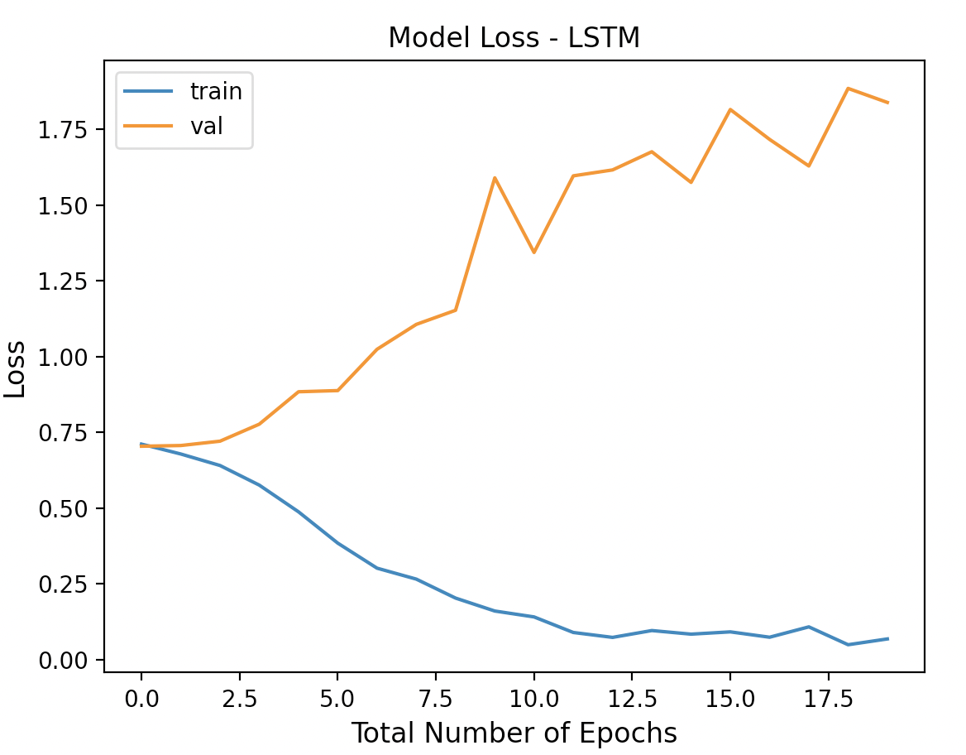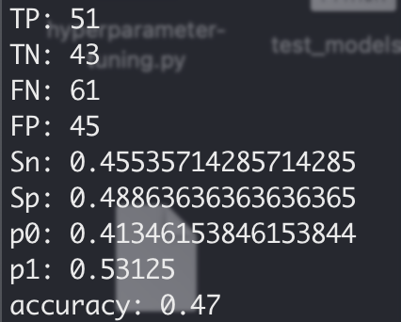

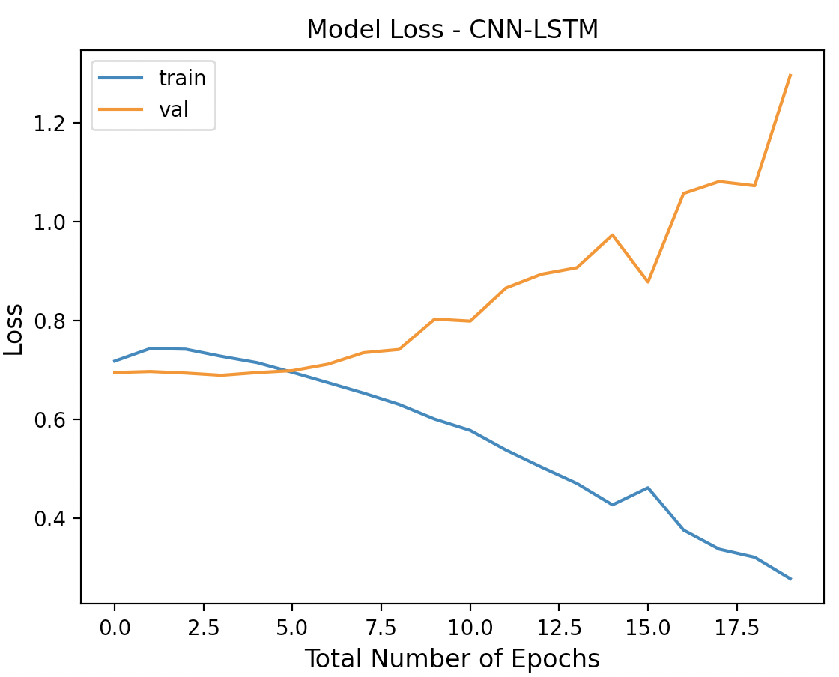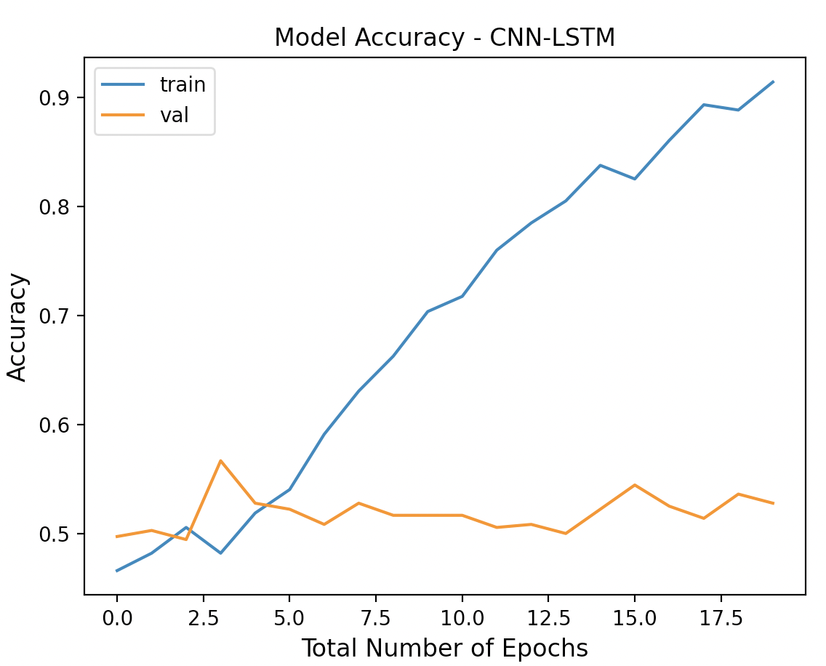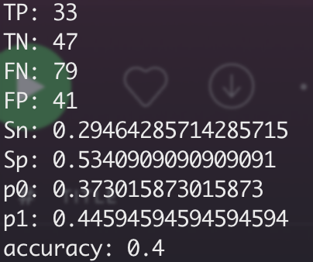

# 100HZ

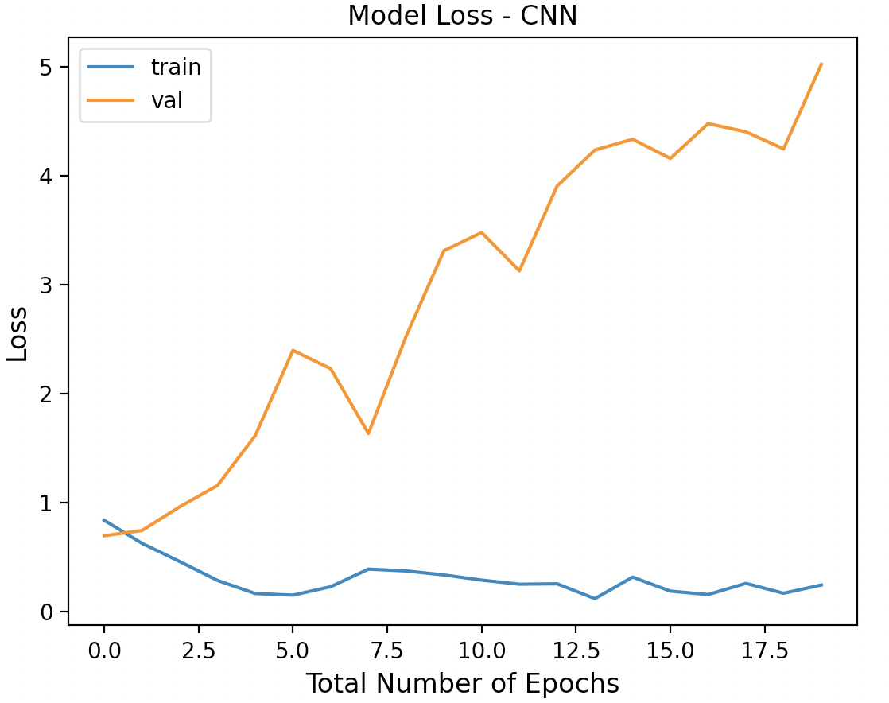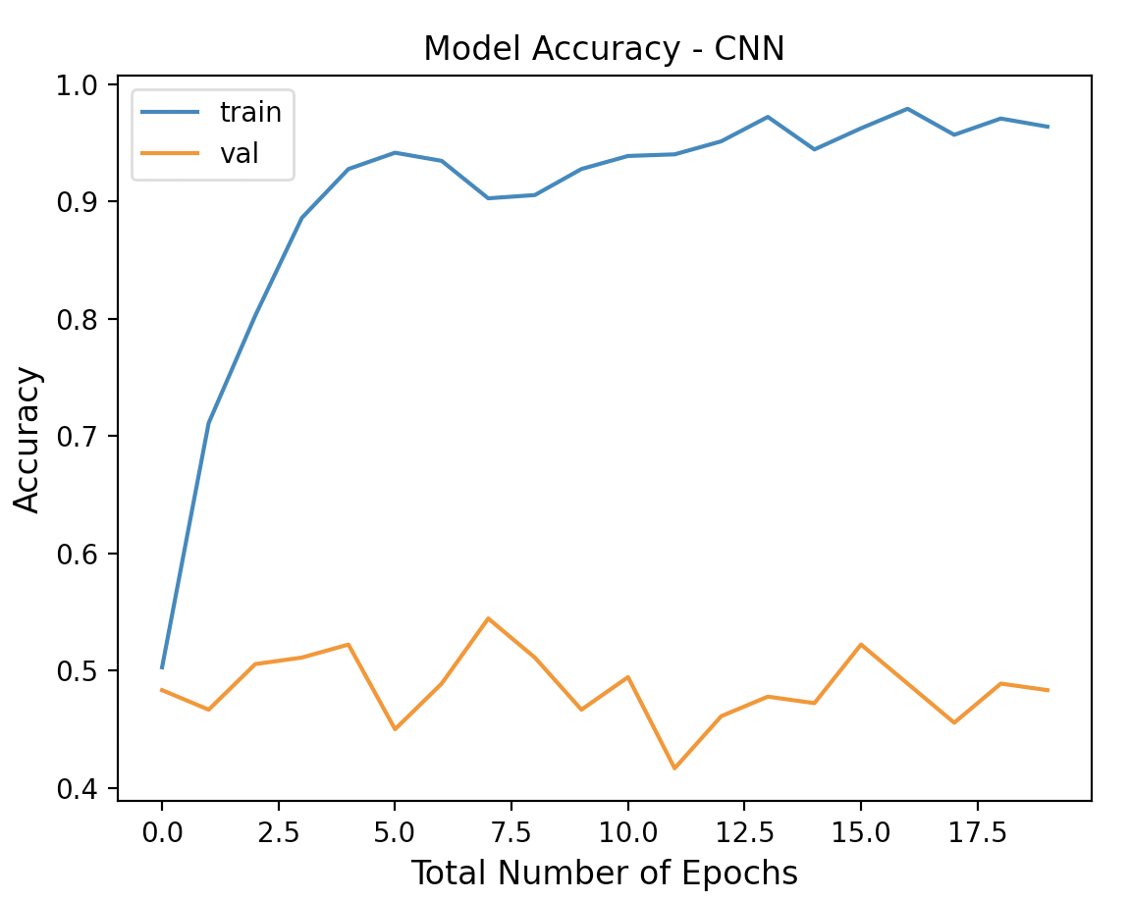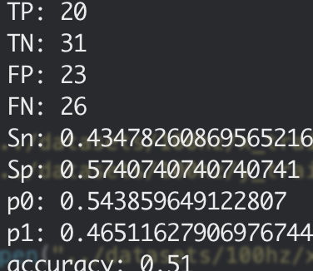

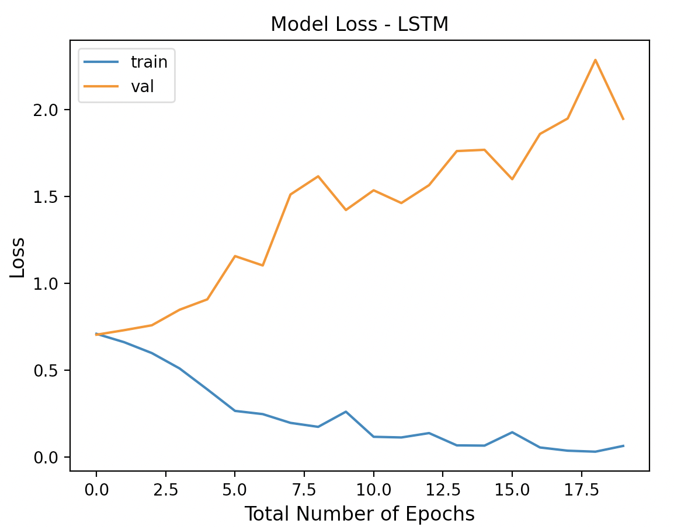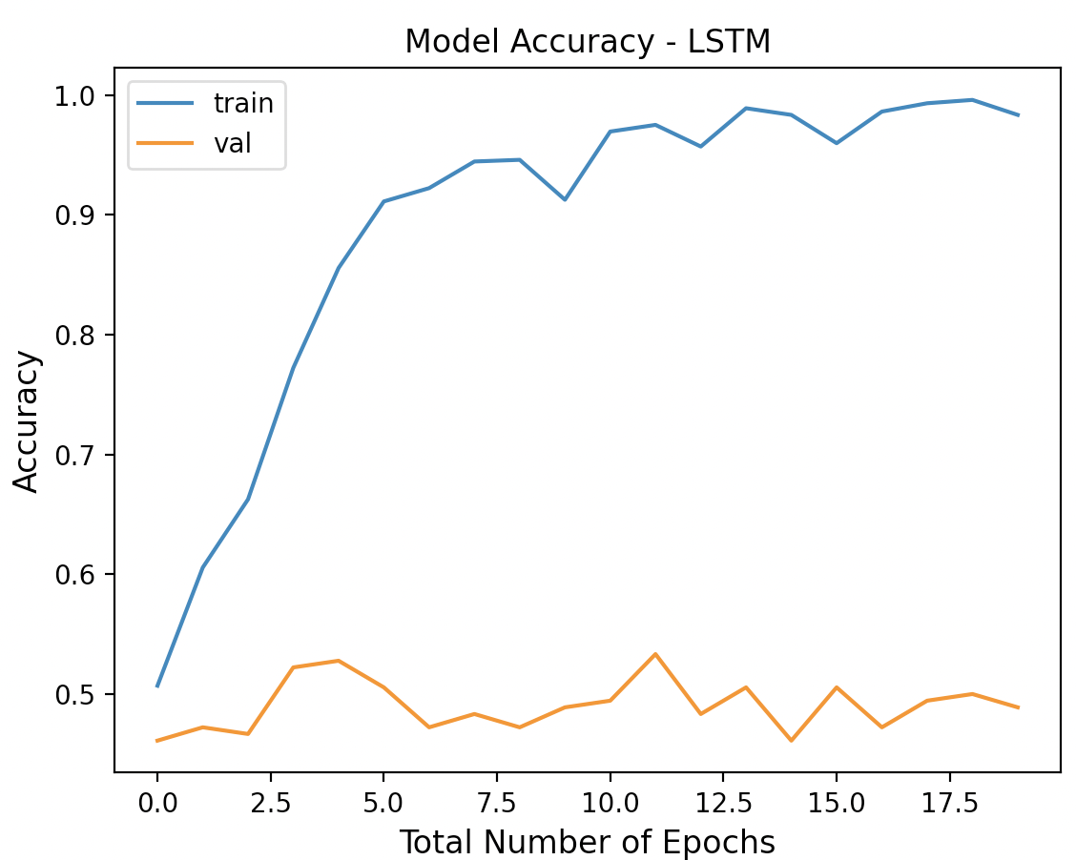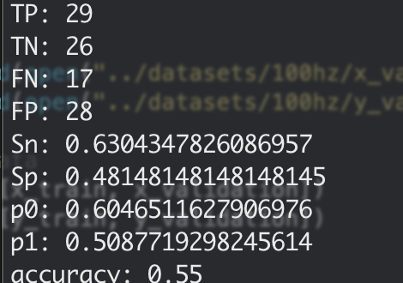

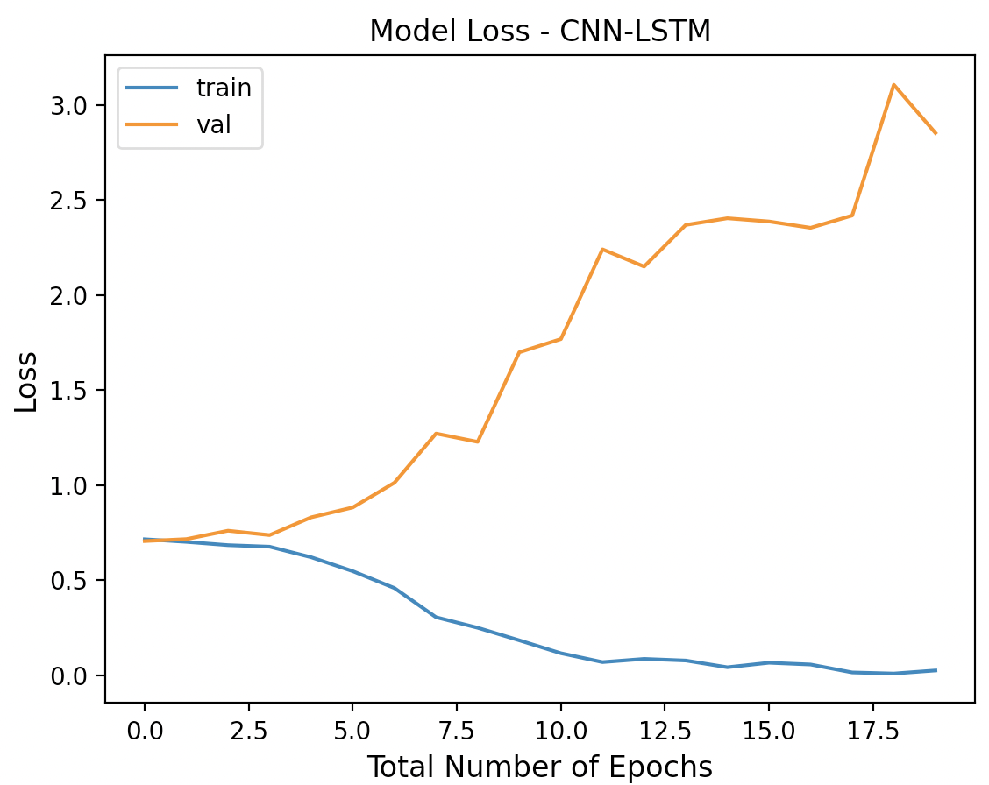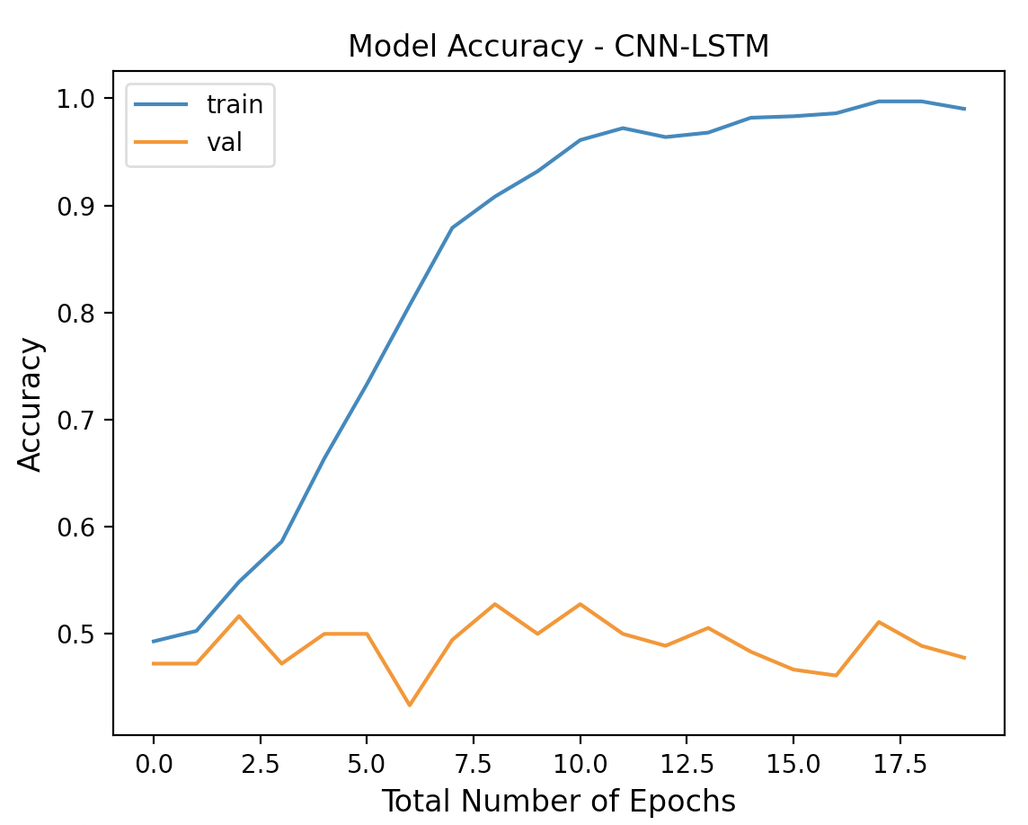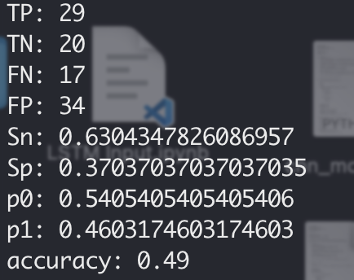

# 

# Feedback

Limitation: only used seismic data as feature

**Presentation Feedback**

- **Why deep neural networks should be used to predict earthquakes? (humans cant detect complex patterns)**

**- you can shorten a bit the introduction / motivation on earthquakes, e.g., your first two bullet points in introduction can be presented shorter**

**- not clear the measurement are taken on different stations; you can show them on top of your NZ map in slide 5 or so**

**- why downsampling to 2Hz**

**- slide 7 - what are the lines on the plot?**

**- why only the weak velocity?**

**Slide 8 : make more clear what is the input-output to the NN before specifying what are they; so everyone gets what you put it and what you get out;**

**- how many waveforms are inputed?**

**- there is some overfitting happening here!**

**- add a conclusion here**



# An LSTM is designed to work differently than a CNN because an LSTM is usually used to process and make predictions given sequences of data (in contrast, a CNN is designed to exploit “spatial correlation” in data and works well on images and speech)

* Cnn looks at small features and then combines them to see patterns in the data
* Lstm is exploits time dependencies
* Sn, also known as the true positive rate (TPR), is the fraction of samples that are genuinely positive and are correctly identified as such.
* Sp, also known as true negative rate (TNR), is the fraction of samples that are genuinely negative and are correctly identified as suc
* The other two most used performance evaluation metrics for predicting earthquakes are **negative predictive value (P0)** and **positive predictive value (P1).**
* P0 is the fraction of true negatives among all the negatives predicted by the model.
* P1 is the fraction of true positives among all the positives predicted by the model